|  |
| --- |
| **Experiment No. : 3**      **Title: Single Server system**  **(The Grocery Store problem)** |

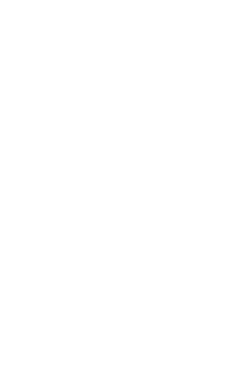

**Batch: A4 Roll No.: 16010420117 Experiment No.:3**

**Aim:** To simulate Single Channel Queuing System

**Resources needed:** Microsoft Excel / Open Office

**Problem Statement:**

A small grocery store has only one checkout counter. Customer arrives at this check out counter at random. In order to evaluate the system performance

1. Let the arrival distribution be uniformly distributed between 1 to 10 minutes.
2. Let service time distribution be as:

|  |  |  |  |  |  |  |
| --- | --- | --- | --- | --- | --- | --- |
| Service  Time(minutes) | 1 | 2 | 3 | 4 | 5 | 6 |
| Probability | 0.05 | 0.1 | 0.2 | 0.3 | 0.25 | 0.1 |

1. Perform simulation for 20 customers and compute the performance measures.

**Concepts:**

The key elements of queuing system are customers & servers. The term customer can refer to people, machines, and trucks. The server might refer to receptionist, person etc.

A queing system is described by its calling population, the nature of the arrivals, the service mechanism, the system capacity and the queing discipline.

1. **Calling population**: The population of potential customer is referred to as calling population. In systems with large population the calling population is usually assumed to be infinity. E.g. population of potential customer of a bank. The actual population may be finite. The main difference between finite & infinite population is based on the definition of the arrival rate.

1. **System Capacity**: The system capacity has no limit meaning that any no. of units comes and waits in the queue. In many queuing system there is a limit to the no. of customers that may be waiting.

1. **Nature of Arrivals**: Arrivals for service occur at a time in random fashion and once they join the waiting line, they are served.

1. **Service Mechanism:** The units are served in order of their arrival by a single server or a channel.
2. **Queuing Discipline:** It refers to the logical ordering of customers that will be chosen for service when a server becomes busy.

1. **State Of System:** It is the no. of units in the system & status of server (busy / idle).

1. **Events:** It is a set of circumstances that causes an instantaneous change in the state of system

Possible events in a single server system:

* The Entry of a unit in the system.
* Departure of unit from system on completion of service.

**8. Simulation Clock**: It is used to track simulation time.

**Conceptual Model:**

The grocery store with one checkout counter is simulated by using a Semi – automatic approach by using simulation table to record successive system snapshots as time advances. The simulation requires mainly a service time distribution and an interarrival time distribution of customers.

**Characteristics of Grocery Store checkout counter System:** I) Calling Population: Infinite.

1. System capacity: Infinite.
2. Nature of Arrival: Random arrival uniformly distributed.
3. Service Mechanism: At a time only one customer is served; service time is random, probability distribution is given. V) Queuing Discipline: FIFO.

**System State:**

1. Waiting time in queue.
2. Status of Able and Baker (Busy / Idle) III) Time customer spends in the system.

**Entities:** The entities in single channel queue are queue & server.

**Events:**

1. Arrival Event
2. Departure Event

**Activities:**

1. Interarrival time.
2. Service time.

**Delay:**

Waiting time in the queue.

**Use of Random Nos.:**

* For generating interarrival time
* For generating service time
* RAND () function of Excel can be used to generate random nos. in simulation.

**Real life Examples**:

1. Customers queuing in the Telephone Bill Payment System Customers form single channel queue. Customer is chosen in FIFO manner.

**Performance measures:**

1. **Average Waiting Time** = (Total time customers wait in queue) / (Total no. of Customers)

1. **Probability. Of Customers waiting** =(No. of Customers who waits) / (Total no. of

Customers)

**3.Probability. Of Idle Server** = (Total Idle Time Of Server) / (Total runtime of simulation)

**4.Average Time between Arrival** = (Total Time between arrivals) / (No. of arrivals)-1

**5.Average Waiting Time of Those Who Wait** = (Total Time Customer waits in queue) /

(Total no. of Customers who wait)

**6.Average Time Customers Spends In System** = (Total Time Customer spends in system) / (Total no. of Customers).

Enters service

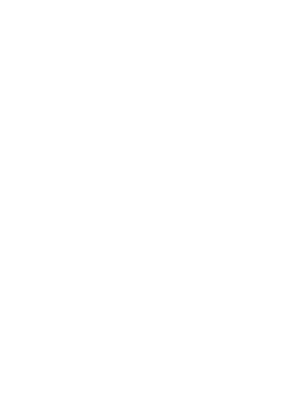

**A**

**c**

**tivity D**

**i**

**ag**

**r**

**a**

**m**

**:**

**1)**

**F**

**lo**

**w**

**c**

**h**

**a**

**r**

**t**

**A**

**r**

**rival**

**e**

**v**

**e**

**n**

**t:**

A

rr

i

v

al

E

v

ent

**NO YES**

S

e

r

v

er

B

us

y

?

U

n

i

t

E

nt

e

r

s

q

u

eue

**2)**

**F**

**lo**

**w**

**c**

**h**

**a**

**r**

**t**

**D**

**e**

**p**

**a**

**r**

**tu**

**r**

**e**

**e**

**v**

**e**

**n**

**t:**

D

epa

rt

u

r

e

E

v

ent

**NO YES**

A

no

t

h

e

r

u

n

i

t

w

a

i

t

i

n

g

?

B

e

g

i

n

s

e

r

v

er

I

d

l

e

T

i

m

e

R

em

o

v

e

w

a

i

t

i

ng

un

i

t

f

r

om

q

u

eue

**Results: (Program printout as per the format) Program:**

*(Problem solved using simulation table and the given inputs with MS-Excel.)*

**Output**:

*(In printed form i.e. Simulation table along with the performance measures and histogram showing number of customers against waiting time)*

**Table for Arrival Time**

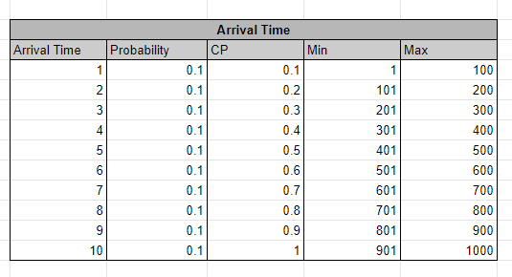

**Table for Service Time**

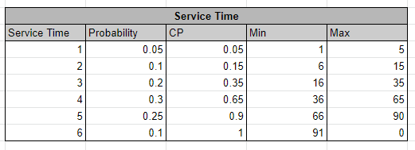

**Simulation Table for 20 Customer**

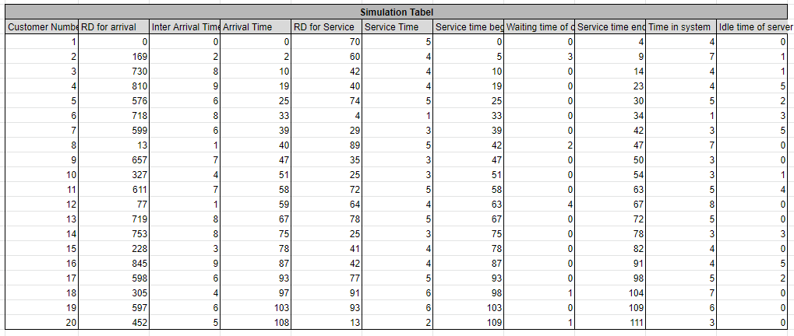

**Bar graph for No. of customers against waiting time in sec**

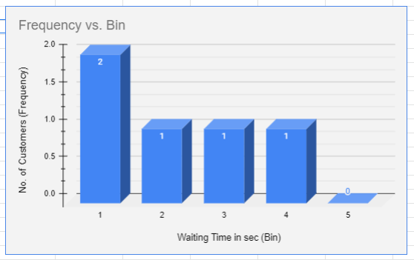

**Performance Measures**

|  |  |
| --- | --- |
| Average waiting time | 1 |
| Probability of customer waiting | 0.25 |
| Probability of server being idle | 0.288 |
| Average time between arrival | 5.684 |
| Average time for those who wait | 2.2 |
| Average time customer spends in the system | 4.55 |

**Questions:**

1. What is simulation? List the different types of simulation.

Ans: Simulation is the process of creating a virtual representation of a system or process, often using a computer, in order to mimic its behavior or performance under different conditions. It allows researchers, engineers, or decision-makers to explore the behavior of a system in a safe, cost-effective, and controlled environment.

There are several types of simulation:

Discrete event simulation (DES): This type of simulation models systems in which events occur at discrete points in time, such as customers arriving at a bank or planes taking off and landing at an airport.

Continuous simulation: In this type of simulation, the system is modeled as a continuous process, such as the flow of fluids through a pipeline.

Monte Carlo simulation: This type of simulation involves randomly generating values for uncertain variables in a model to determine the probability of different outcomes.

Agent-based simulation: In this type of simulation, the behavior of individual agents or entities is modeled, and the interactions between them are used to understand the behavior of the system as a whole.

Physical simulation: This involves constructing physical models to simulate the behavior of a system or process, such as wind tunnel testing of aircraft designs or crash testing of automobiles.

Virtual reality simulation: This type of simulation creates a fully immersive, 3D environment that allows users to interact with a system or process in a virtual space, often used for training purposes or entertainment.

Each type of simulation has its own strengths and limitations and is suited to different types of problems and applications.

2) List the queue disciplines used in simulation?

Ans: Queue discipline, also known as queuing discipline or service discipline, refers to the rules that determine how customers are served in a queue. The following are some of the commonly used queue disciplines in simulation:

First-In-First-Out (FIFO): This is the most common queue discipline, where the customer who has been waiting the longest is served first.

Last-In-First-Out (LIFO): This queue discipline serves the most recent customer first, which is also known as a "stack."

Priority Queue: In this queue discipline, customers are served according to their priority, such as emergency cases in a hospital or business class passengers on a flight.

Round Robin: This queue discipline cycles through customers in a fixed order, such as serving customers in turns.

Shortest Processing Time (SPT): This queue discipline serves the customer with the shortest processing time first, which is also known as "min-heap."

Longest Processing Time (LPT): In this queue discipline, the customer with the longest processing time is served first.

Processor Sharing: In this queue discipline, each customer is served for a small time interval, and the service is rotated among customers in a fixed order.

The choice of queue discipline can significantly affect the performance of a system or process, such as the waiting time of customers and the utilization of resources. Therefore, it is important to carefully select the appropriate queue discipline based on the characteristics of the system being modeled and the objectives of the simulation.

**Outcomes:** CO1: Apply the experimental process of a simulation using spreadsheets as well as

Simulation language/package.

**Conclusion:** Successfully understood how simulations words for single channel queuing system



**G**

**r**

**a**

**d**

**e**

**:**

**AA / AB /**

**B**

**B /**

**B**

**C / CC**

**/ CD /DD**

**S**

**ig**

**n**

**a**

**t**

**u**

**r**

**e**

**of**

**f**

**a**

**c**

**u**

**lty**

**in**

**-**

**c**

**h**

**a**

**r**

**ge**

**w**

**ith**

**d**

**a**

**t**

**e**

**References:**

**Books/ Journals/ Websites:**

1. Jerry Banks, John Carson, Barry Nelson, and David M. Nicol; “Discrete Event System Simulation”, Fifth Edition, Pearson Education.
2. Jerry Banks, John Carson, Barry Nelson, and David M. Nicol; “Discrete Event System Simulation”, Third Edition, Pearson Education.
3. Real Queuing Examples[:http://www2.uwindsor.ca/hly](http://www2.uwindsor.ca/)nka/qreal.html This site contains excerpts from news articlesthat deal with aspects of waiting lines.
4. ClearQ [:http://clearq.com/ This co](http://clearq.com/)mpany produces “take-a-number” systems for servicefacilities (e.g., delis), but also providesperformance information about the waiting line.
5. Qmatic[:http://us.q-matic.com/index.htmlThis](http://us.q-matic.com/index.html)company produces informational displays andother products to keep customers informedabout waiting times.
6. “Queuing Presentation” by Richard Larson, givenat the Institute for Operations Research and the Management.
7. cienc[es:http://caes.mit.edu/people/larson/MontrealINFORMS1/sld001.htm.](http://caes.mit.edu/people/larson/MontrealINFORMS1/sld001.htm)
8. Queuing Tutor [:http://www.dcs.ed.ac.uk/home/jeh/Simjava/queueing/](http://www.dcs.ed.ac.uk/home/jeh/Simjava/queuei)mm1_q/mm1_q.html This site has twoanimated displays of waiting lines. The user canchange arrival and service rates to see howperformance is affected.
9. Myron Hlynka‟s Queuing Page:http:www2.uwindsor.ca/hlynka/queue.html This web site contains information about waiting linesas well as links to other interesting sites.
10. Queuing ToolP[ak:http://www.bus.ualberta.ca/aingolfsson/qtp/](http://www.bus.ualberta.ca/aingolfsson/qtp/)
11. The Queuing ToolPak is an Excel add-in that allowsyou to easily compute performance measures fora number of different waiting line models

KJSCE/IT/TY BTECH/SEMVI/MS/2022-23

**(A Constituent College of Somaiya Vidyavihar University)**